**HIVE CASE STUDY**

**EMR CLUSTER CREATION**

**STEP 1:** Login to your AWS account & search EMR services. After the EMR home page appears click on **Create cluster** & follow the steps as mentioned. We have chosen cluster release version **5.29.0** in our case study.

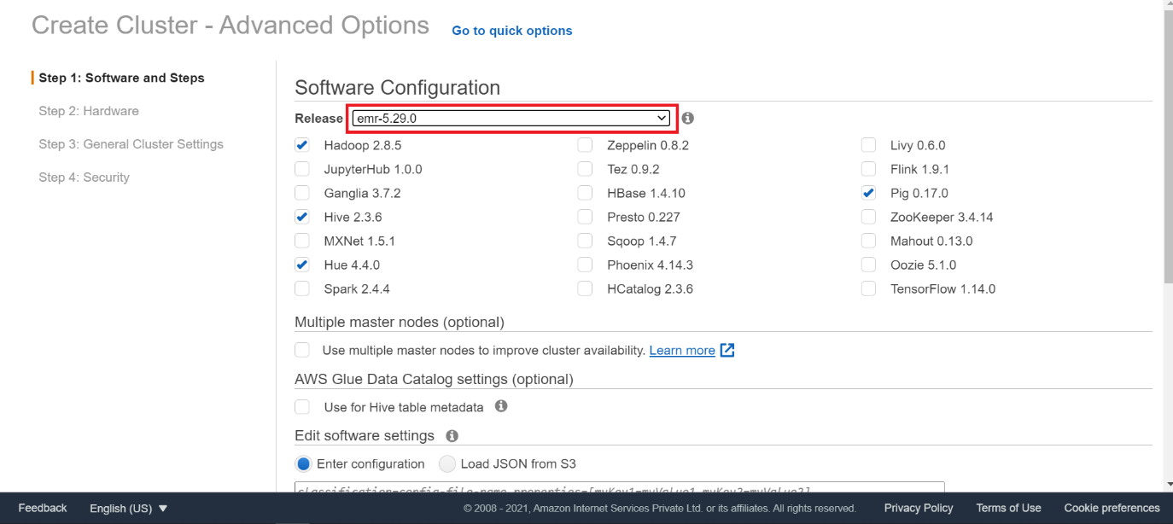

**STEP 2:** We will be going for a **2-node cluster** for our analysis & we will select **m4.large** instance type each for both master & core node.

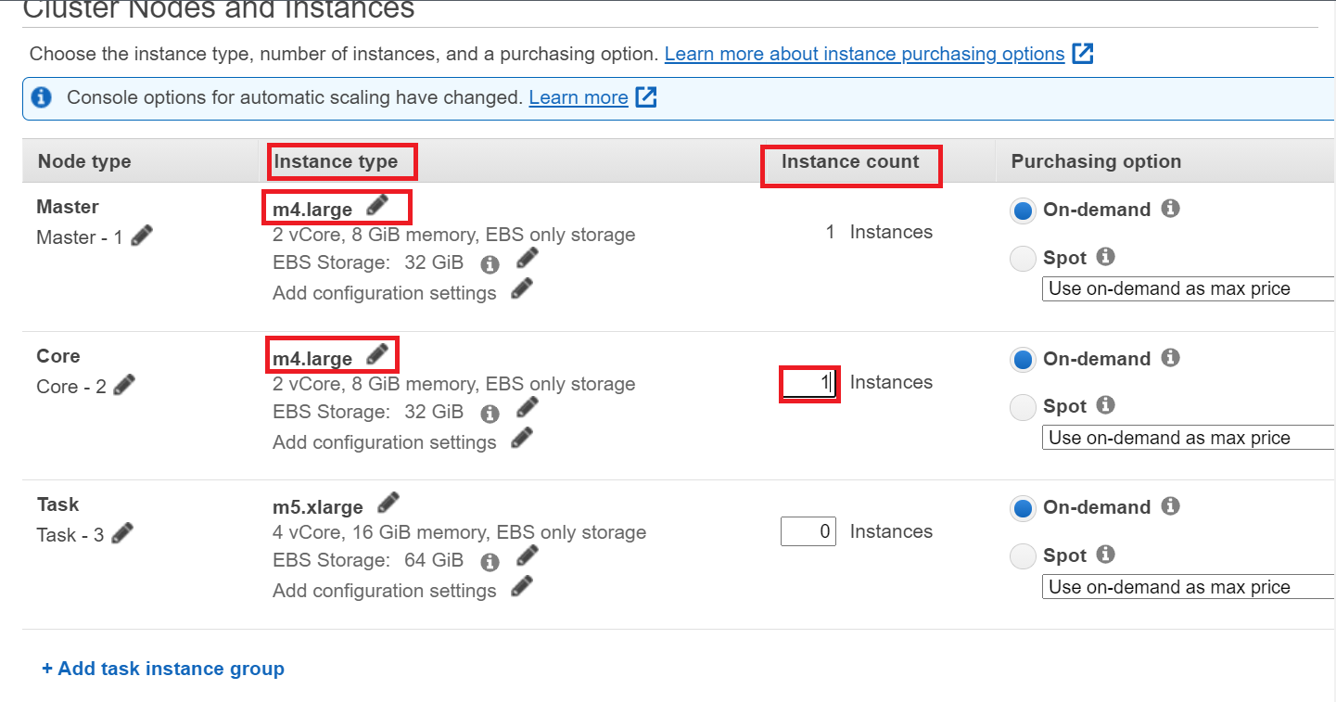

**Step 3:** Select a cluster name. Here we have taken the cluster name as **My cluster***.*

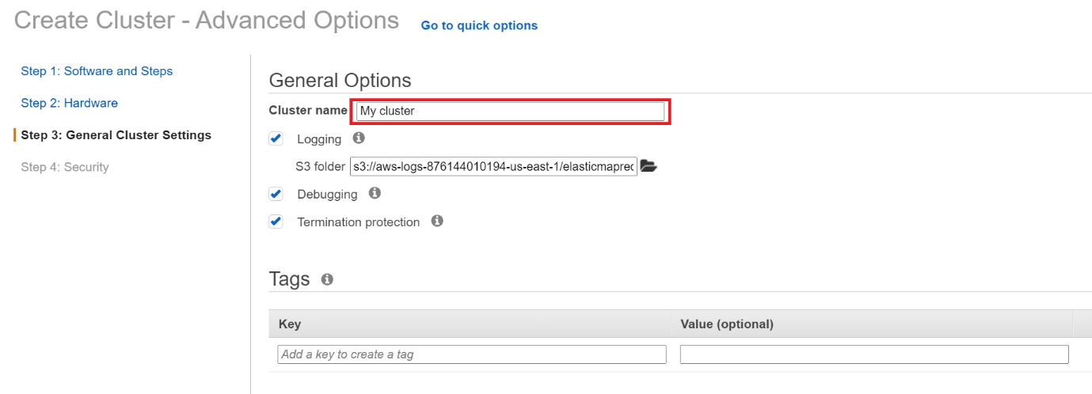

**Step 4:** Select an already created key-pair which will be used while connecting to master node and **hive_test** is the name of the key that we have used.

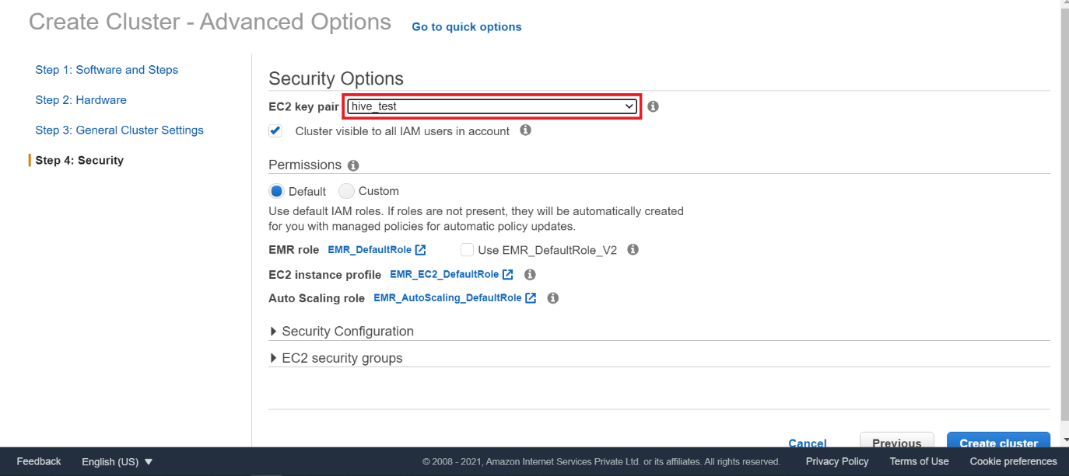

**Step 5:** Our cluster has been created successfully and is in **waiting state** which indicates its ready to be connected from the local system.

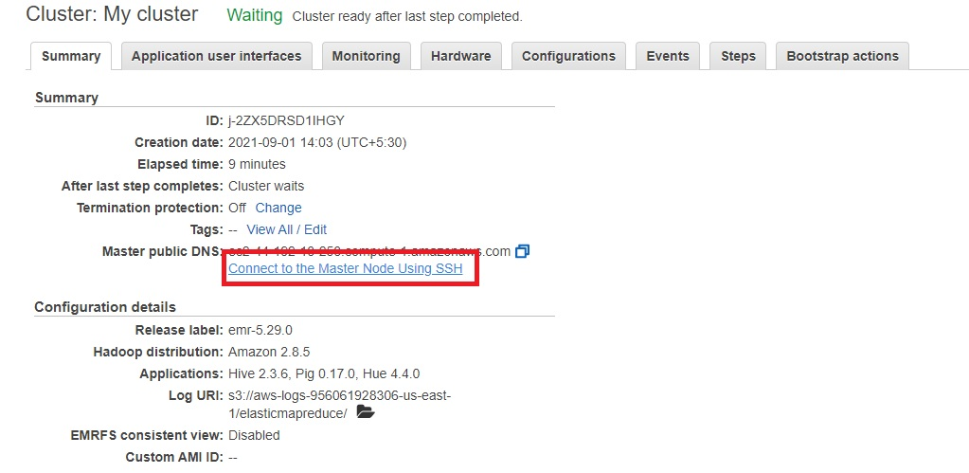

**Step 6:** Copy the highlighted link i.e., the master public DNS.

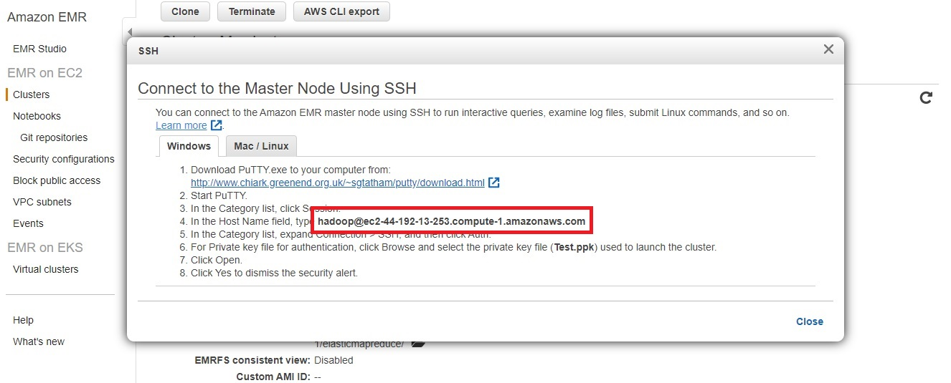

**Step 7:** Next, paste the address in the **Host Name** field.

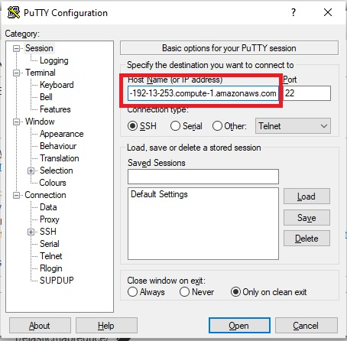

**Step 7:** Click on **SSH** & then **Auth**. Give the location where the key pair is stored in the local system and click on **Open.**

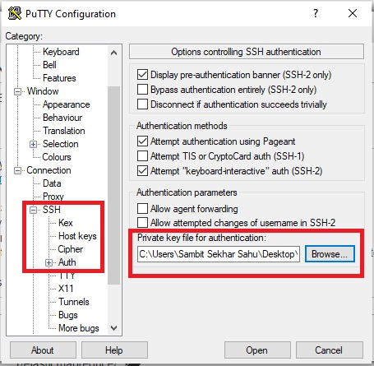

**Step 8:** Next click on Accept which will open the SSH terminal.

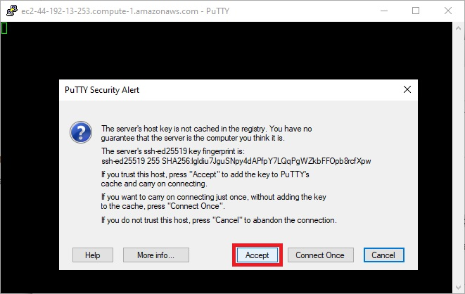

After we have created an EMR cluster & successfully connected to it via putty we can begin to code in the SSH Terminal.

**DATA LOADING INTO S3 BUCKET**

*aws s3 cp s3://e-commerce-events-ml/2019-Oct.csv s3://casestudy-data/2019-oct.csv*

*aws s3 cp s3://e-commerce-events-ml/2019-Nov.csv s3://casestudy-data/2019-nov.csv*



using the above code, we could directly copy the data files into Hadoop without actually downloading the data files into our system, and the copying completes instantly.

**WORKING WITH HDFS**

* **Creating a folder in Hadoop**

*hadoop fs -mkdir /cstudy-folder*

*hadoop fs -ls /*

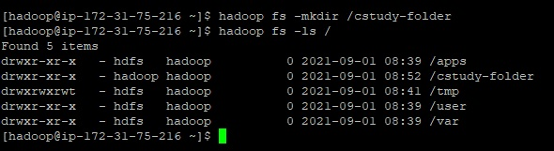

* **Copying October & November data from S3 bucket into HDFS**

*hadoop distcp s3://casestudy-data/2019-oct.csv /cstudy-folder/2019-oct.csv*

*hadoop distcp s3://casestudy-data/2019-nov.csv /cstudy-folder/2019-nov.csv*

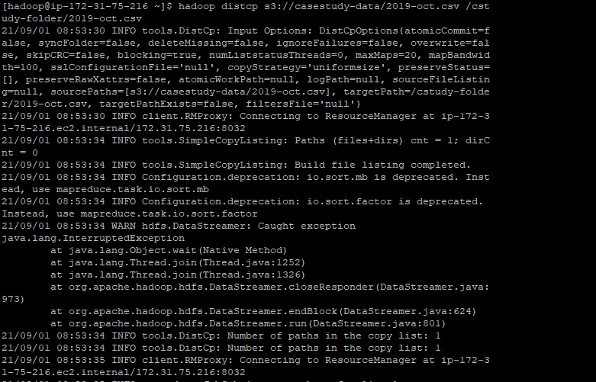

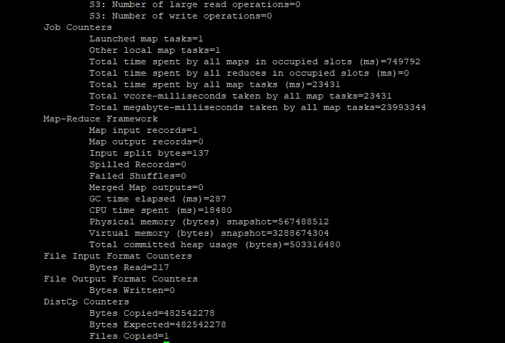

*Similarly, November data file was also copied, as shown in above image.*

* **Verifying if data has been copied successfully**

*hadoop fs -ls /cstudy-folder*

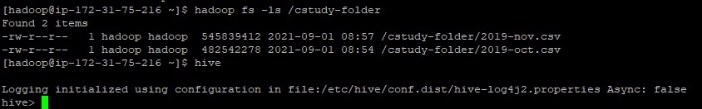

**WORKING ON HIVE**

* **Getting into Hive CLI – making a new database named *cstudy***

*create database if not exists cstudy ;*

*use cstudy ;*

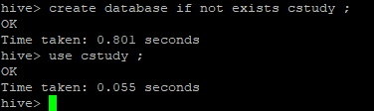

* **Creating a common table named clickstream and storing both October & November data in it**

*create external table if not exists clickstream( event_time timestamp, event_type string, product_id string, category_id string, category_code string, brand string, price float, user_id bigint, user_session string ) ROW FORMAT SERDE 'org.apache.hadoop.hive.serde2.OpenCSVSerde' WITH SERDEPROPERTIES ('separatorChar'= ',', 'escapeChar'= '\\') stored as textfile LOCATION 'hdfs:///cstudy-folder/' tblproperties ( 'skip.header.line.count' = '1' ) ;*

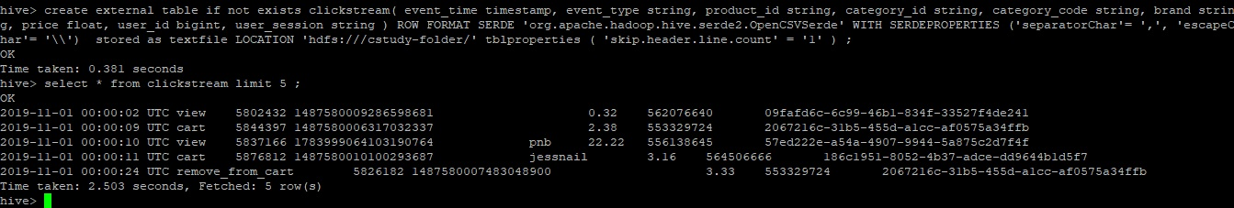

* **To create optimised table having partitions & buckets we need to enable some settings**

*set hive.exec.dynamic.partition = true ;*

*set hive.exec.dynamic.partition.mode = nonstrict ;*

*set hive.enforce.bucketing = true ;*

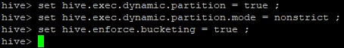

* **Creating table with dynamic partitions and buckets and inserting data into it**

*create table if not exists dynpart_buck_clickstream (event_time string, product_id string, category_id string, category_code string, brand string, price float, user_id bigint, user_session string ) partitioned by (event_type string) clustered by (category_code) into 13 buckets row format delimited fields terminated by ',' lines terminated by '\n' stored as textfile;*

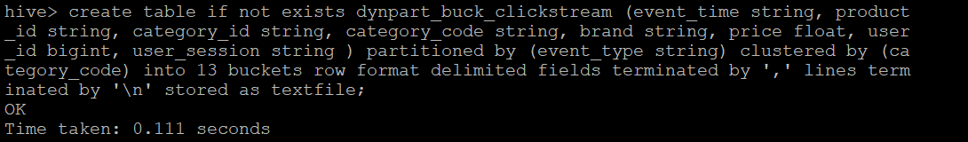

*insert into table dynpart_buck_clickstream partition (event_type) select event_time, product_id,category_id,category_code,brand,price,user_id,user_session,event_type from clickstream ;*

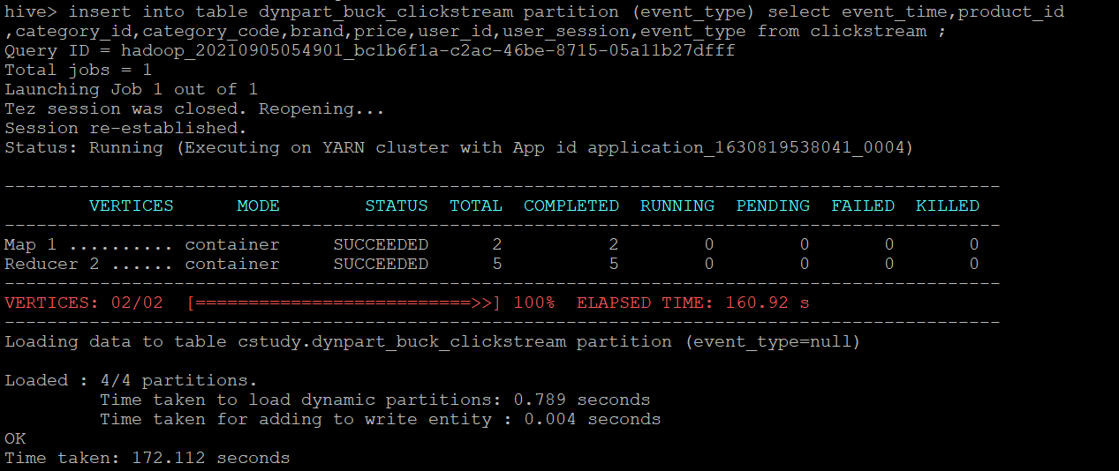

* **Describing both tables**

*describe clickstream;*

*describe dynpart_buck_clickstream;*

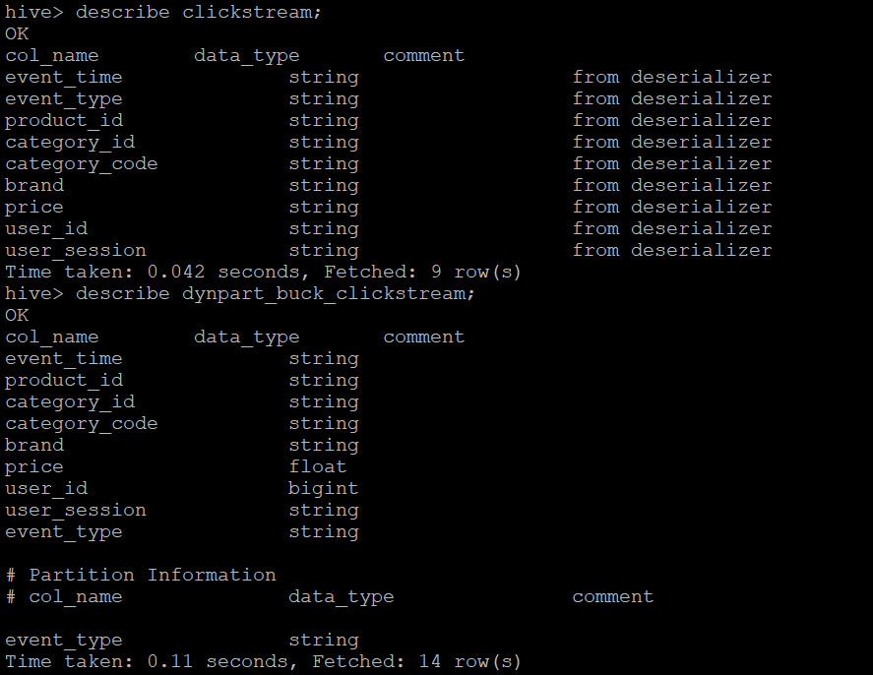

* **Checking data in both tables**

*set hive.cli.print.header=true;*

*select * from clickstream limit 5 ;*

*select * from dynpart_buck_clickstream limit 5 ;*

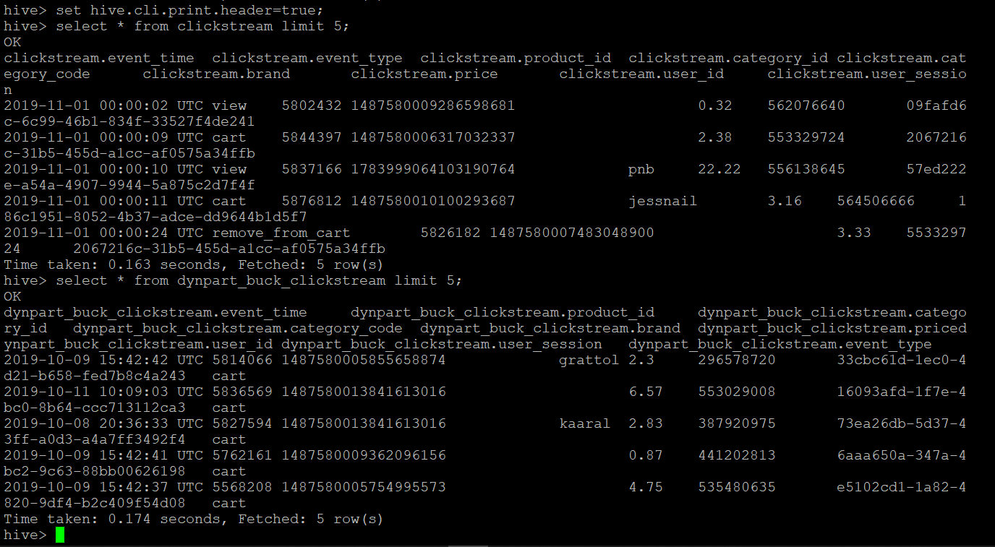

* **Checking if partitions were created successfully**

*show partitions dynpart_buck_clickstream;*

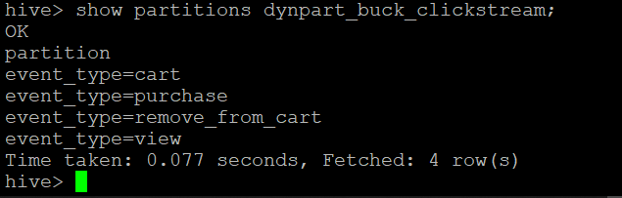

* **Checking in Hadoop if partitions were created successfully**

*hadoop fs -ls /user/hive/warehouse/cstudy.db/dynpart_buck_clickstream*

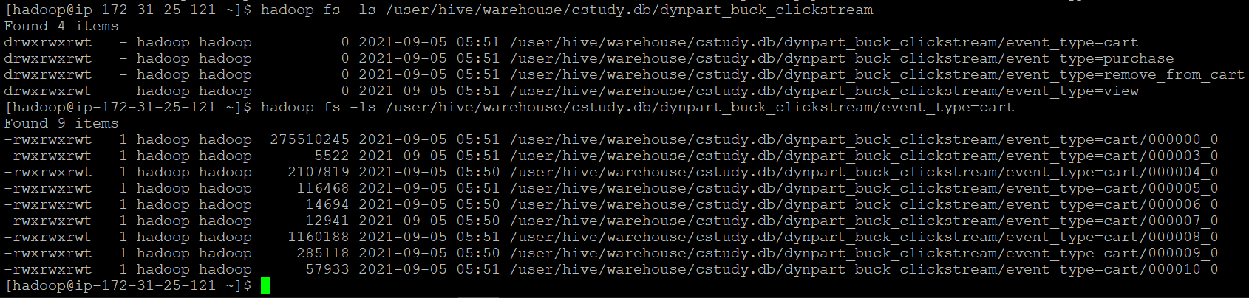

Overall, we have made two tables,

* One common table named **clickstream** which contains data of both October & November.
* One table with partitions & buckets named **dynpart_buck_clickstream** for optimised querying which also contains data of both October & November.

So, all the preparations are done & now we can move to query analysis-

**QUERY ANALYSIS**

1. **Find the total revenue generated due to purchases made in October.**
2. *Unoptimized query:*

*select sum(price) as total_revenue_oct from clickstream where event_type='purchase' and month(event_time)=10 ;*

*and month(event_time)=10 ;*

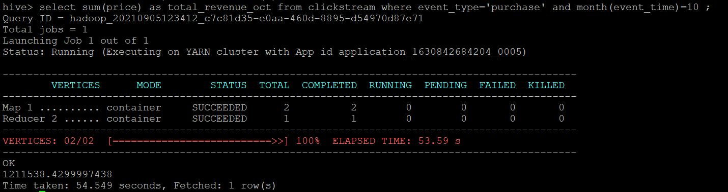

1. *Optimized query:*

*select sum(price) as total_revenue_oct from dynpart_buck_clickstream where event_type='purchase' and month(event_time)=10 ;*

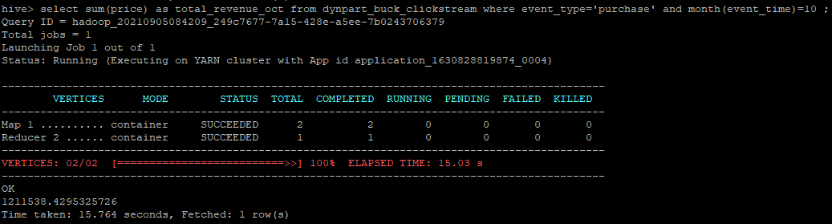

Optimized query using dynpart_buck_clickstream table

*The total revenue generated in October is* ***1211538.429.*** *Optimized query took* ***15.764 secs*** *while unoptimized query took* ***54.549 secs*** *to fetch the same result.*

1. **Write a query to yield the total sum of purchases per month in a single output.**
2. *Unoptimized query:*

*select month(event_time) as month, sum(price) as total_revenue from clickstream where event_type='purchase' group by month(event_time);*

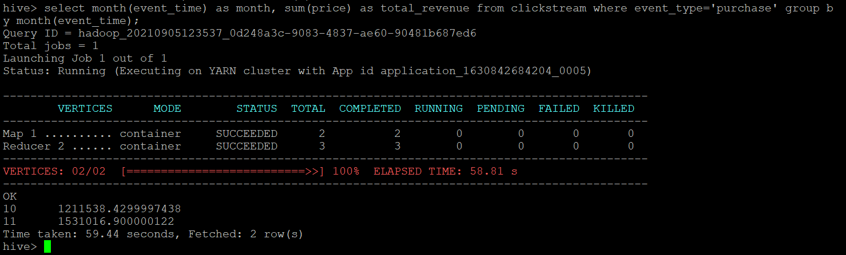

1. *Optimized query:*

*select month(event_time) as month, sum(price) as total_revenue from dynpart_buck_clickstream where event_type='purchase' group by month(event_time);*

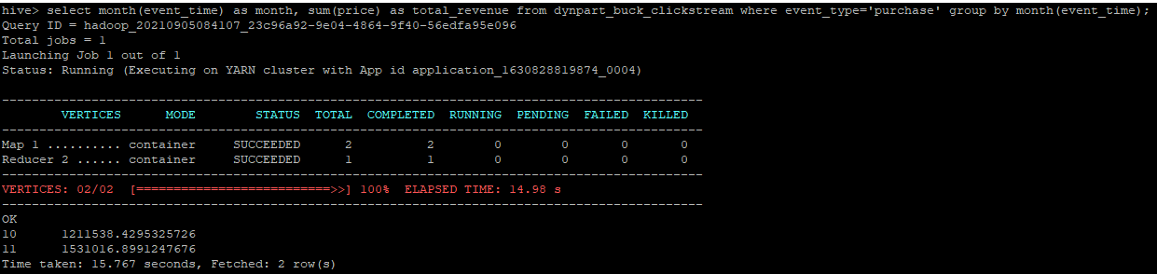

Optimized query using dynpart_buck_clickstream table

*Total sum of purchases for* ***October*** *is* ***1211538.429*** *while for the* ***November*** *it’s* ***1531016.899.*** *Optimized query took* ***15.767 secs*** *while unoptimized query took* ***59.44 secs****.*

1. **Write a query to find the change in revenue due to purchases from October to November.**
2. *Unoptimized query:*

*select (sum(case when month(event_time)=11 then price else 0 end) - sum(case when month(event_time)=10 then price else 0 end)) as change_in_revenue from clickstream where event_type='purchase' ;*

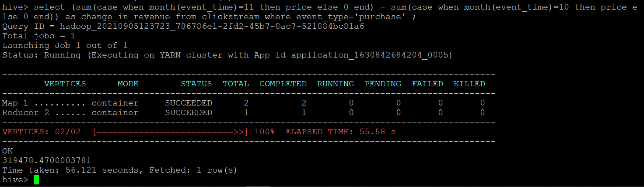

1. *Optimized query:*

*select (sum(case when month(event_time)=11 then price else 0 end) - sum(case when month(event_time)=10 then price else 0 end)) as change_in_revenue from dynpart_buck_clickstream where event_type='purchase' ;*

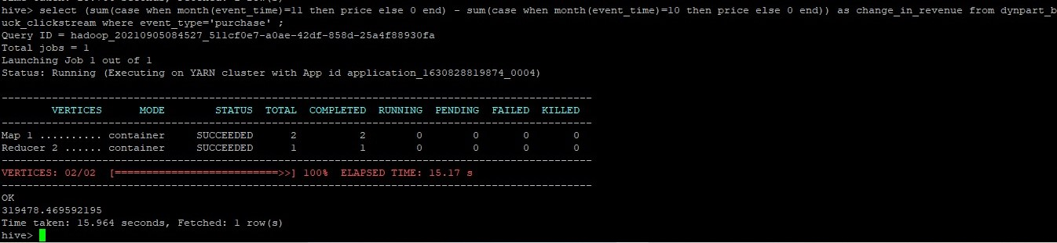

Optimized query using dynpart_buck_clickstream table

*Change in revenue is* ***319478.469****. Optimized query took* ***15.964 secs*** *while unoptimized query took* ***56.121 secs****.*

1. **Find distinct categories of products. Categories with null category code can be ignored.**
2. *Unoptimized query:*

*select distinct(category_code) from clickstream where category_code != '' ;*

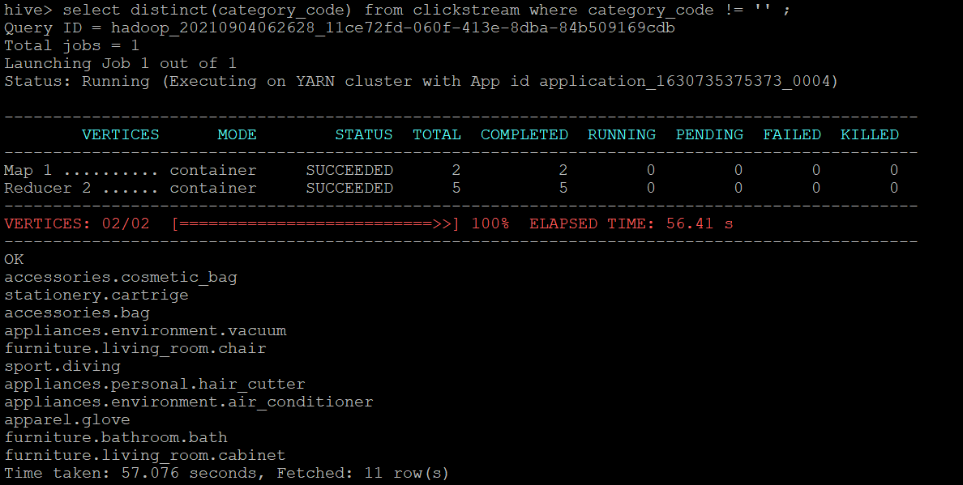

1. *Optimized query:*

*select distinct(category_code) from dynpart_buck_clickstream where category_code != '' ;*

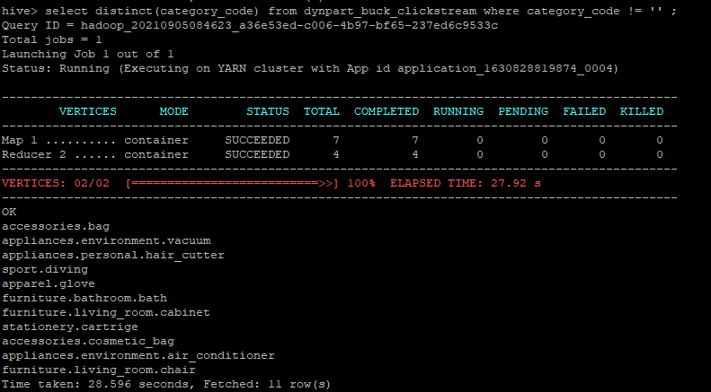

Optimized query using dynpart_buck_clickstream table

*There are* ***11 distinct categories****. Optimized query took* ***28.596 secs*** *while unoptimized query took* ***57.076 secs****.*

1. **Find the total number of products available under each category.**
2. *Unoptimized query:*

*select category_code, count(product_id) as total_products from clickstream where category_code != '' group by category_code ;*

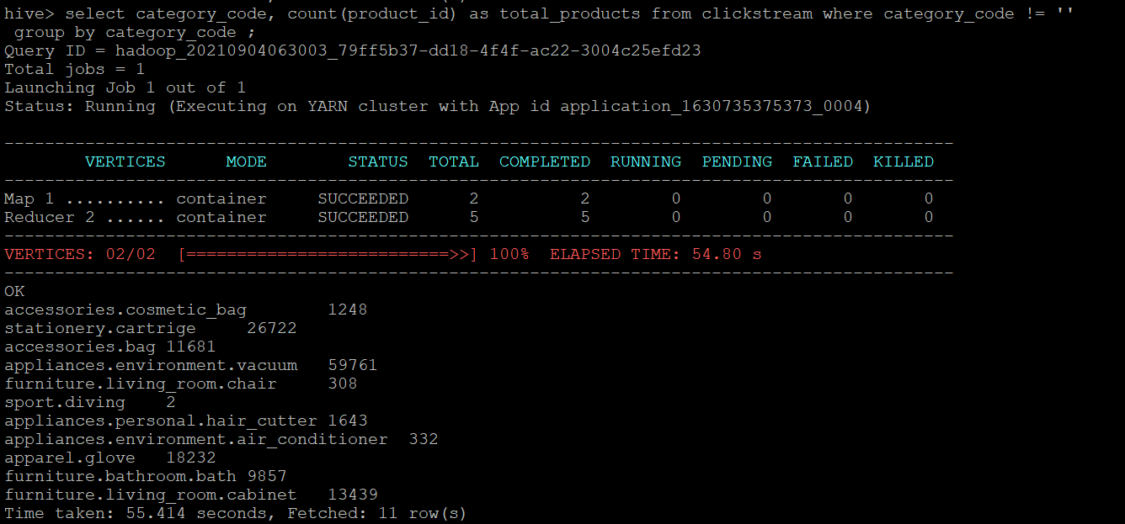

1. *Optimized query:*

*select category_code, count(product_id) as total_products from dynpart_buck_clickstream where category_code != '' group by category_code ;*

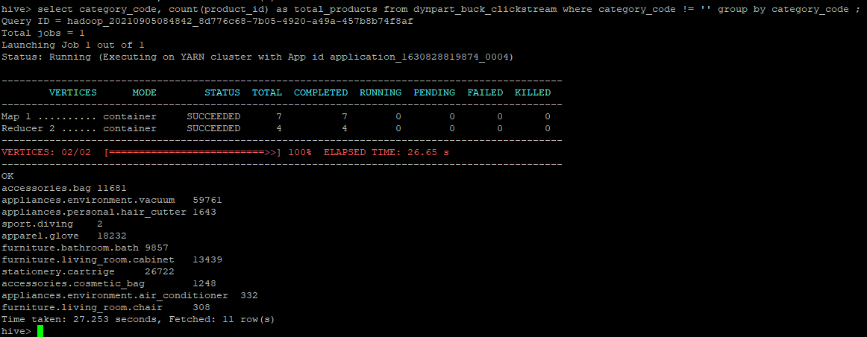

Optimized query using dynpart_buck_clickstream table

*Optimized query took* ***27.253 secs*** *while unoptimized query took* ***55.414 secs****.*

1. **Which brand had the maximum sales in October and November combined?**
2. *Unoptimized query:*

*select brand, sum(price) as total_sales from clickstream where event_type='purchase' and brand != '' group by brand order by total_sales desc limit 1 ;*

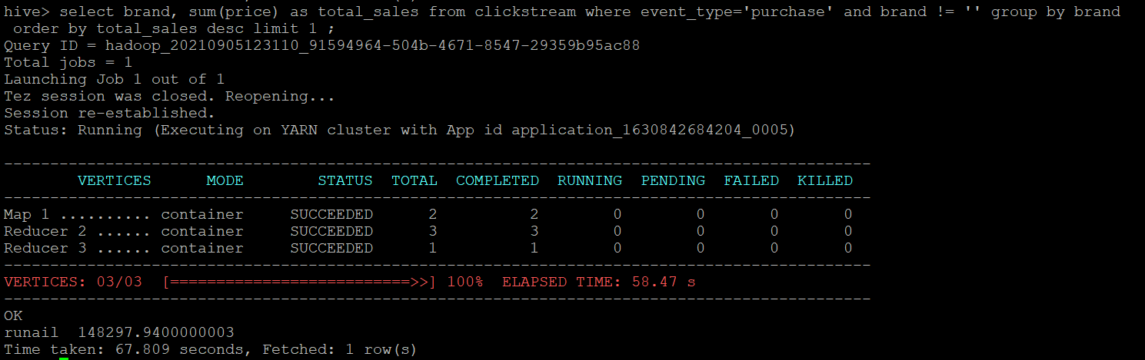

1. *Optimized query:*

*select brand, sum(price) as total_sales from dynpart_buck_clickstream where event_type='purchase' and brand != '' group by brand order by total_sales desc limit 1 ;*

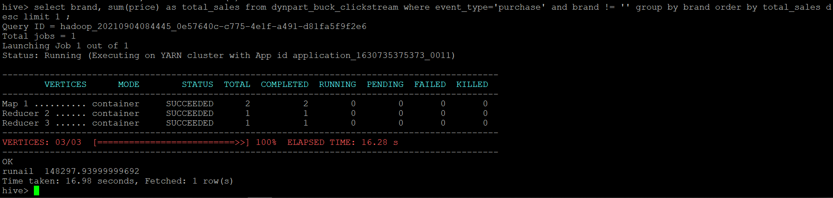

Optimized query using dynpart_buck_clickstream table

*The top brand is* ***runail*** *with* ***total_sales 148297.939*** *& to show this optimized query took* ***16.98 secs*** *while unoptimized query took* ***67.809 secs.***

1. **Which brands increases their sales from October to November?**
2. *Unoptimized query:*

*with brand_sales_summary as ( select brand, sum(case when month(event_time)=10 then price else 0 end) as oct_sales, sum(case when month(event_time)=11 then price else 0 end) as nov_sales from clickstream where event_type='purchase' group by brand ) select brand from brand_sales_summary where (nov_sales-oct_sales)>0 ;*

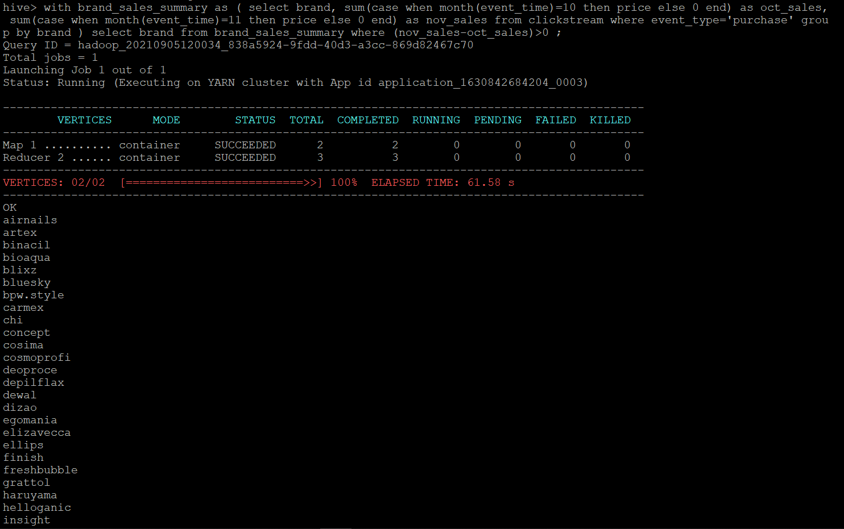

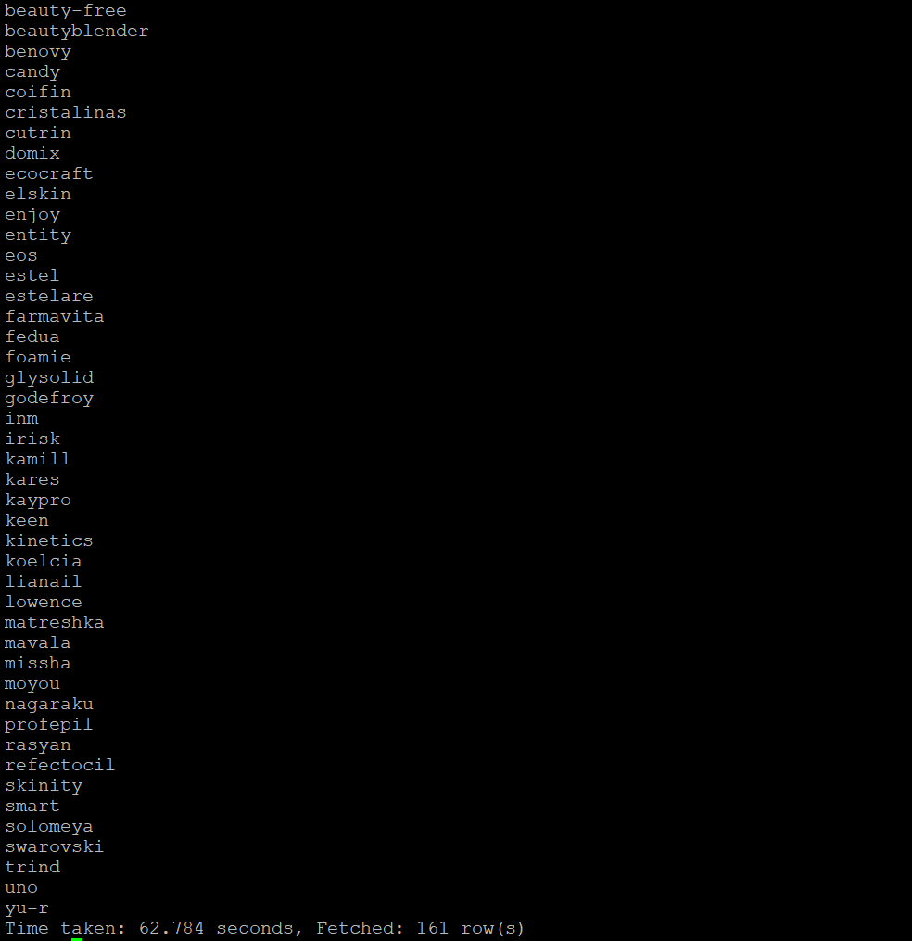

1. *Optimized query:*

*with brand_sales_summary as ( select brand, sum(case when month(event_time)=10 then price else 0 end) as oct_sales, sum(case when month(event_time)=11 then price else 0 end) as nov_sales from dynpart_buck_clickstream where event_type='purchase' group by brand ) select brand from brand_sales_summary where (nov_sales-oct_sales)>0 ;*

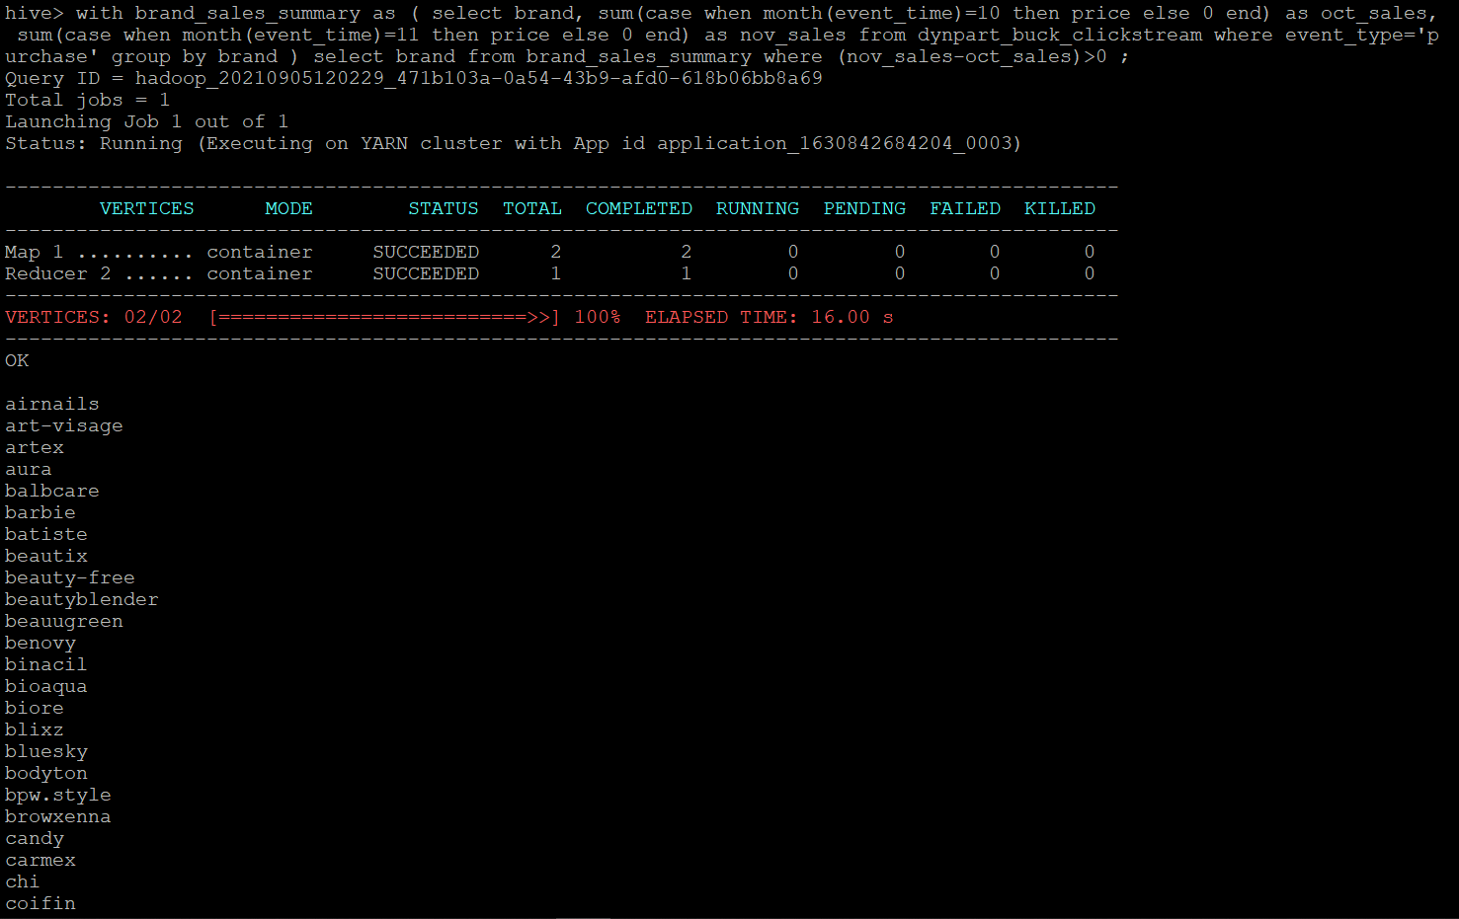

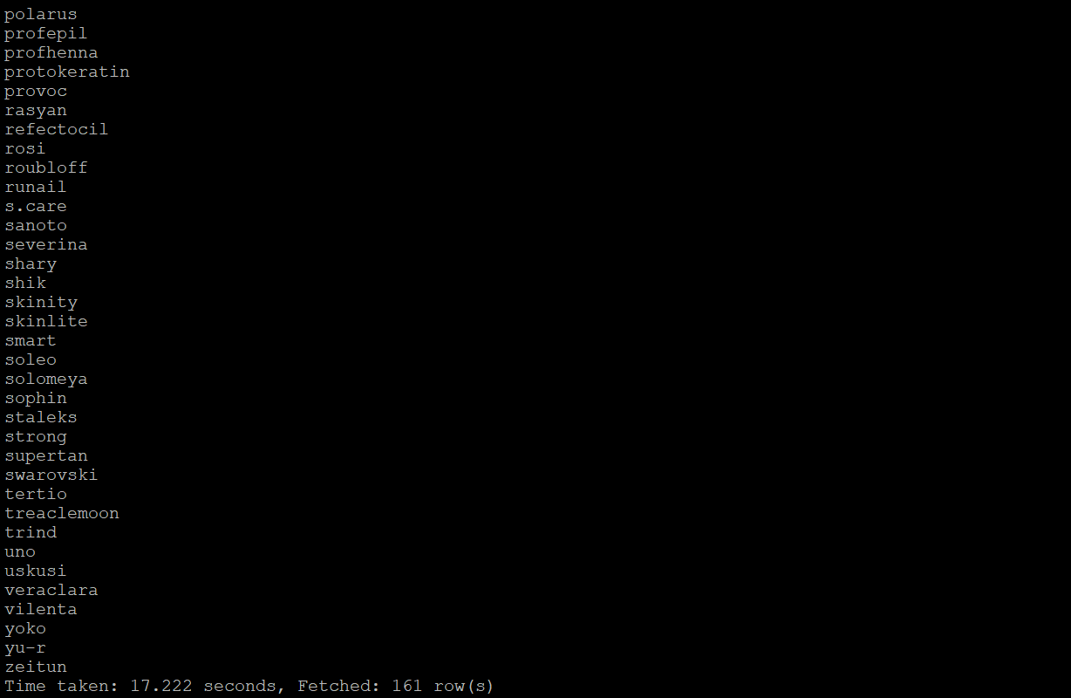

*There is a total of* ***161 brands*** *that had increased sales from October to November.*

*To show this optimized query took* ***17.222 secs*** *while unoptimized query took* ***62.784 secs.***

1. **Your company wants to reward the top 10 users of its website with a Golden Customer plan. Write a query to generate a list of top 10 users who spend the most.**
2. *Unoptimized query:*

*with spending_summ as (select user_id, sum(price) as overall_spending from clickstream where event_type='purchase' group by user_id order by overall_spending desc) select user_id from spending_summ limit 10 ;*

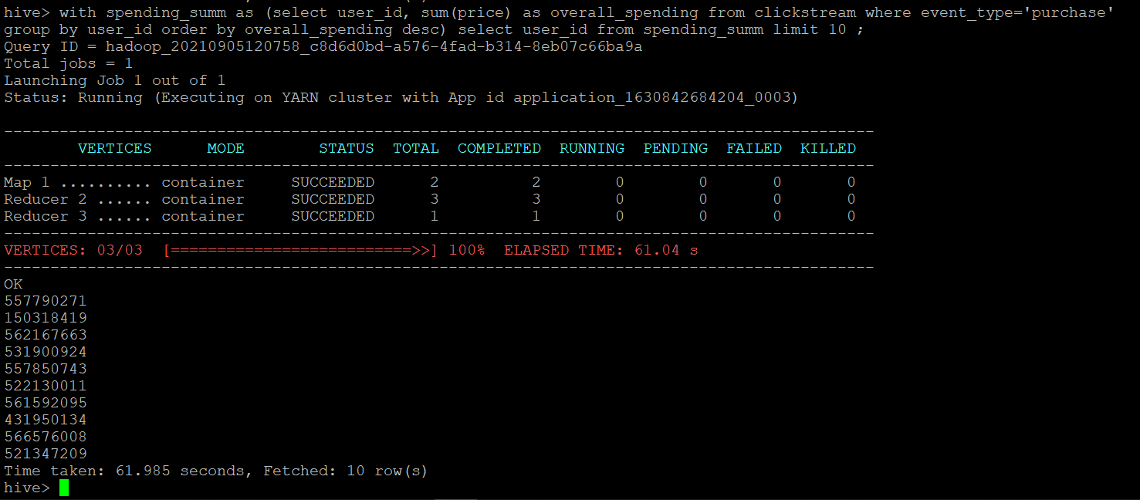

1. *Optimized query:*

*with spending_summ as (select user_id, sum(price) as overall_spending from dynpart_buck_clickstream where event_type='purchase' group by user_id order by overall_spending desc) select user_id from spending_summ limit 10 ;*

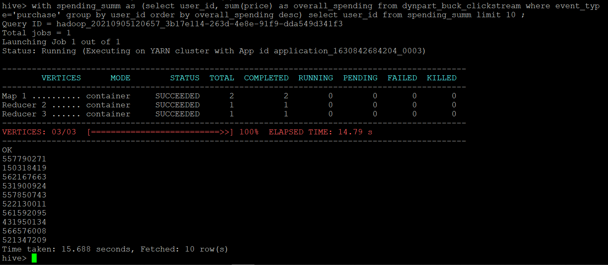

Optimized query using dynpart_buck_clickstream table

*So above are the top 10 customers who spend the most and should be awarded with golden customer plan. To show this the optimized query took* ***15.688 secs*** *while unoptimized query took* ***61.985 secs****.*

* **Dropping database**

*drop database cstudy cascade;*

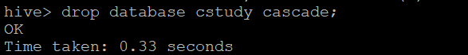

*show databases;*

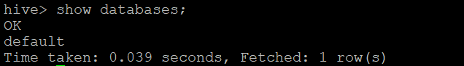

We are done with our analysis. Finally, we will move towards terminating our cluster

**TERMINATING THE EMR CLUSTER**

**Step 1:** Click on Terminate.

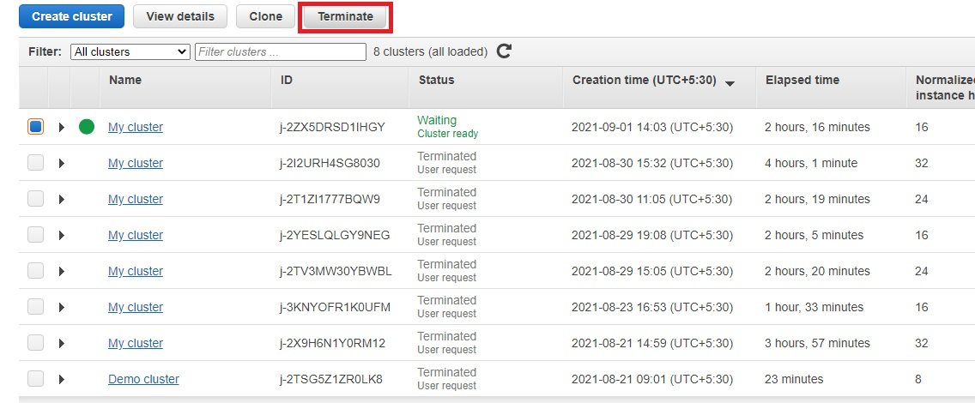

**Step 2:** A security/confirmation message will pop up. Click on Terminate.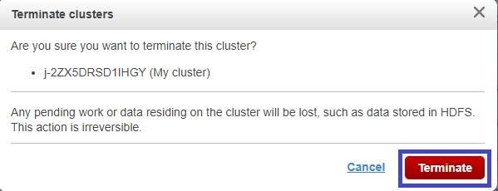

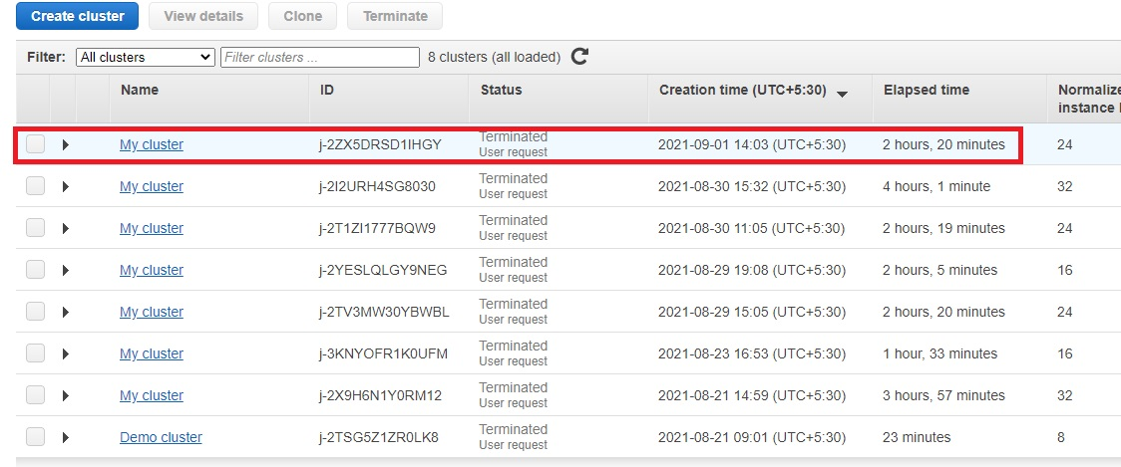

The Cluster has been terminated. Now we can log out of our AWS account.